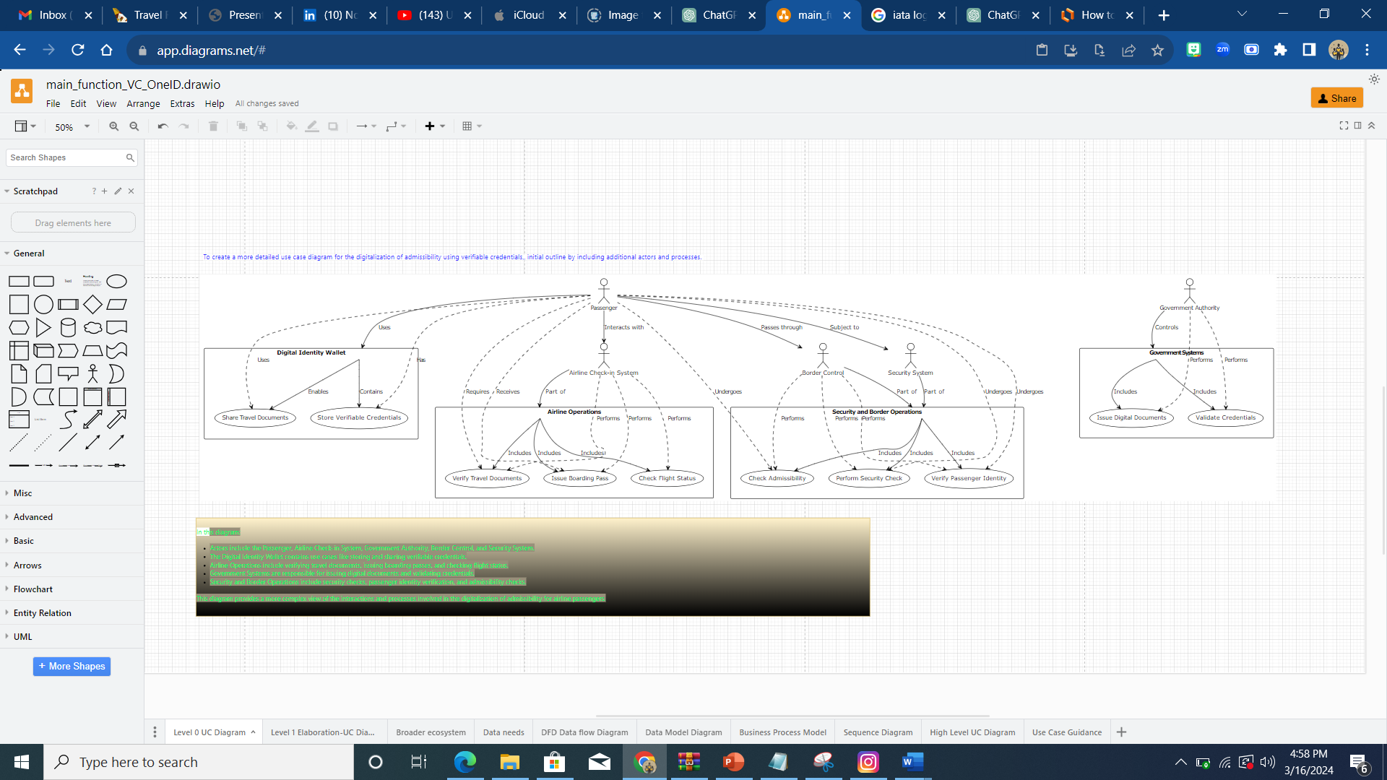

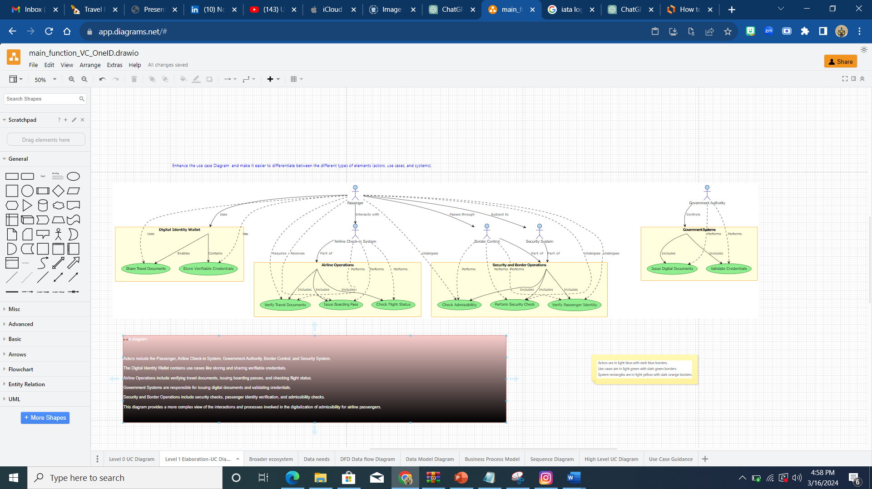

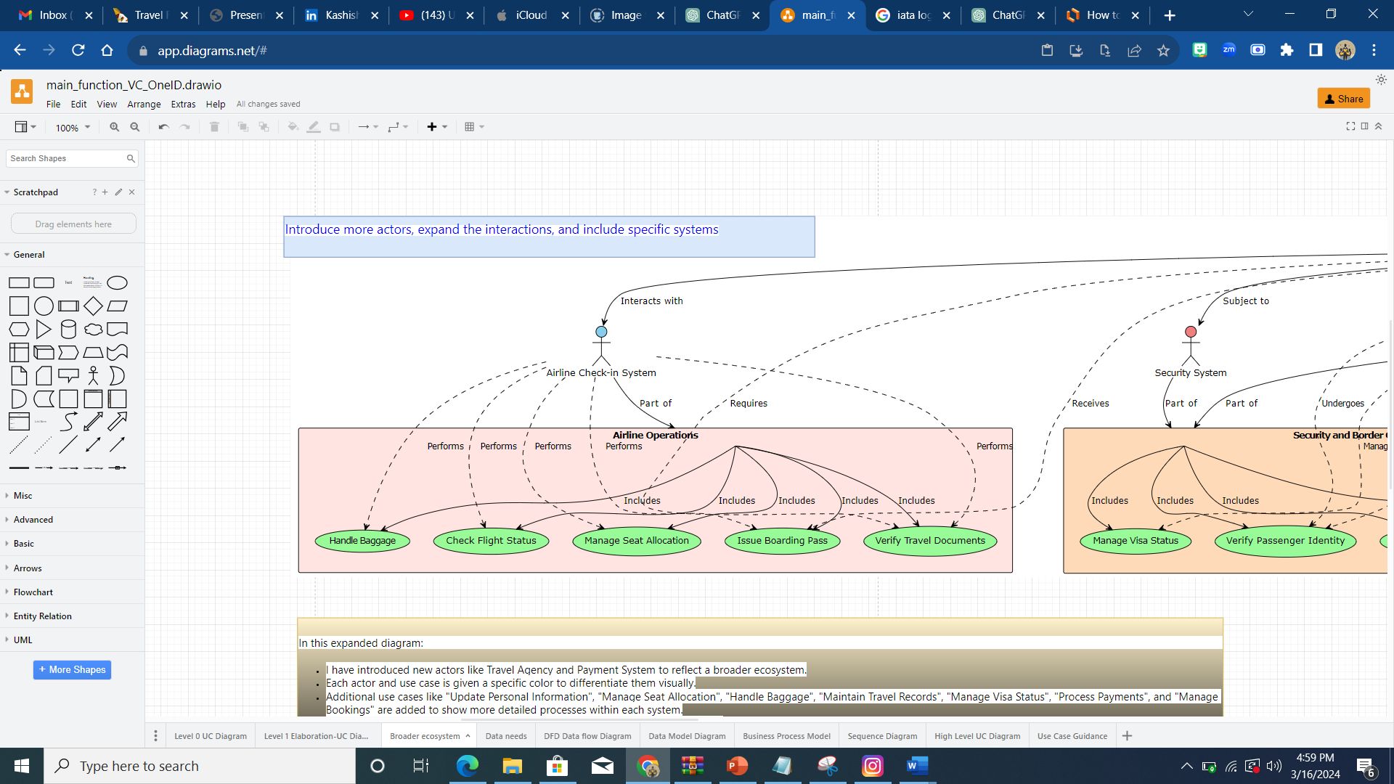

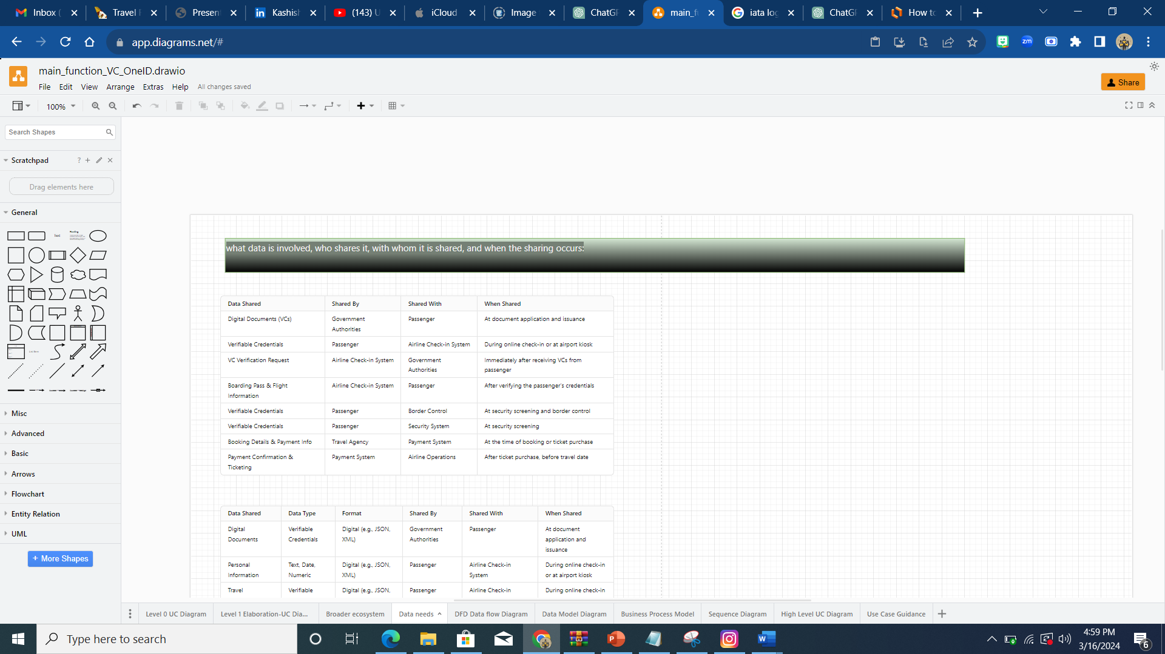

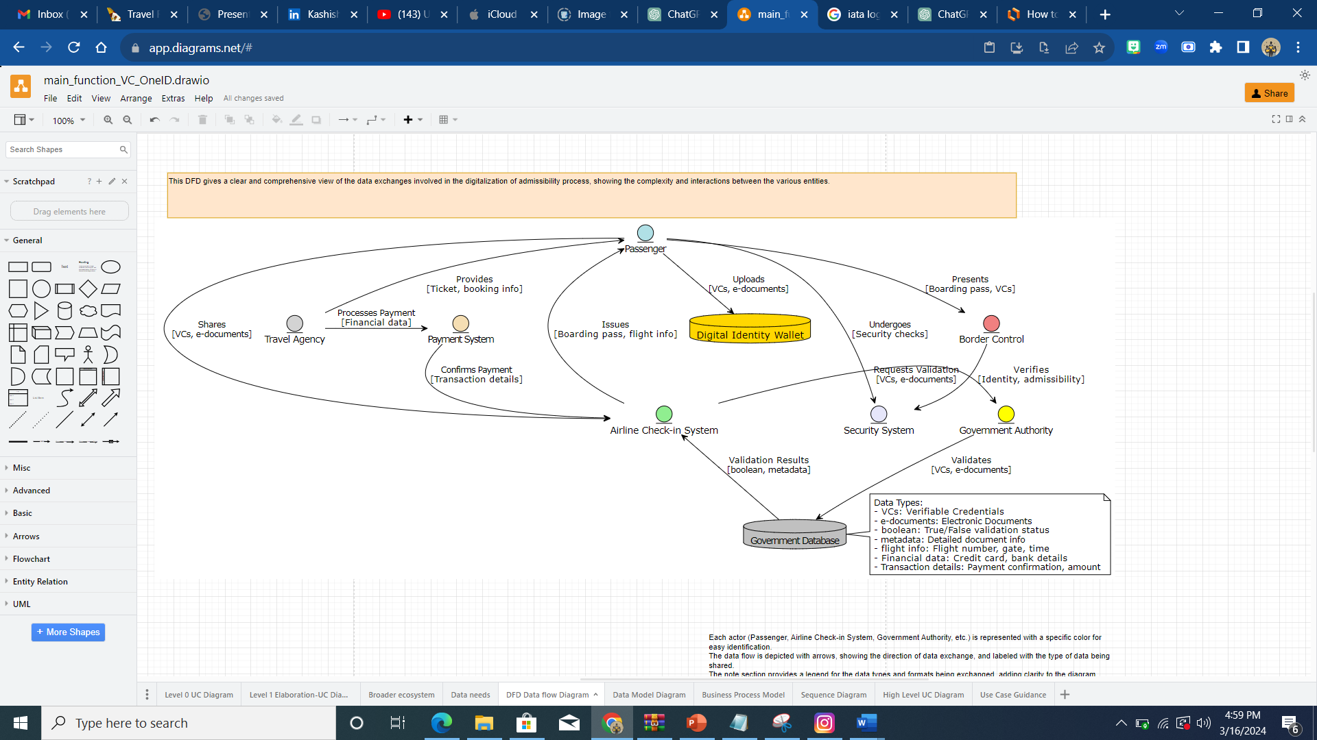

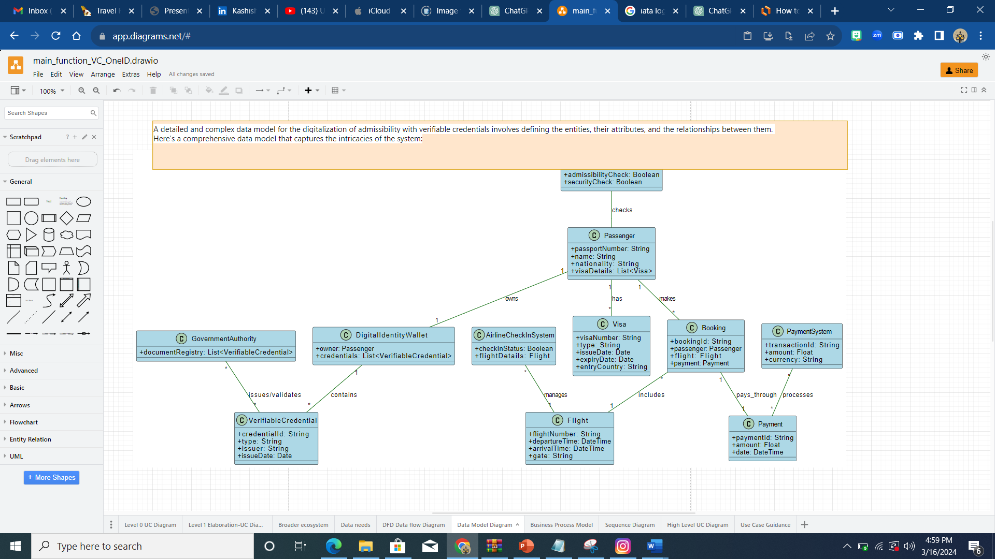

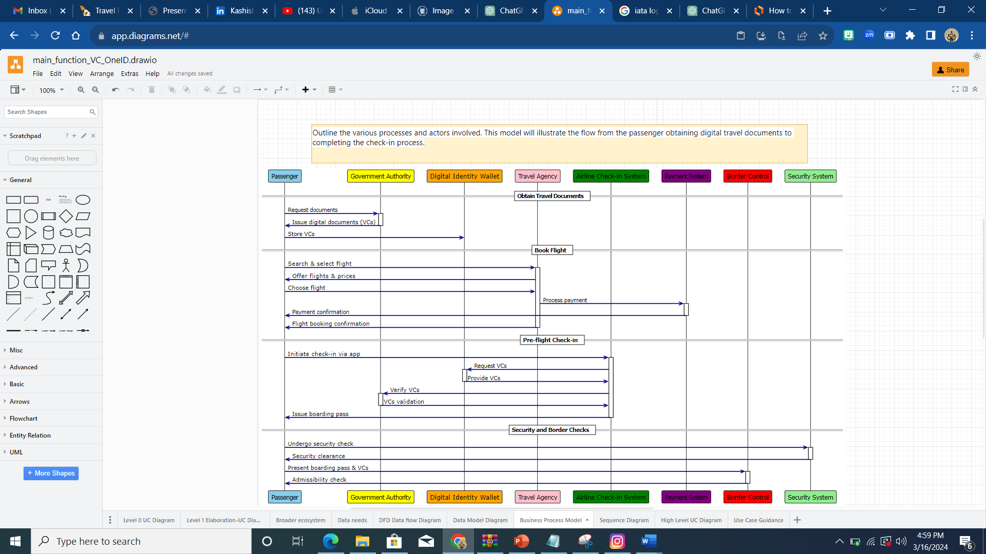

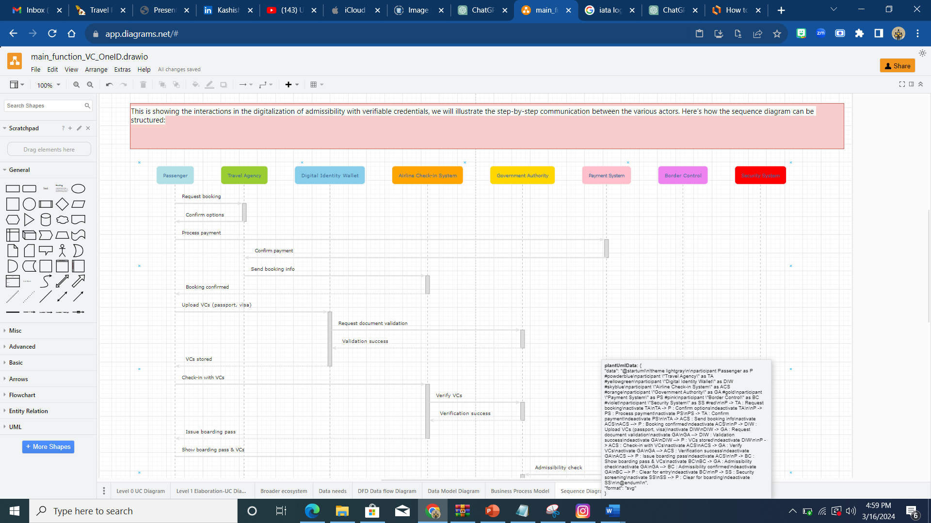

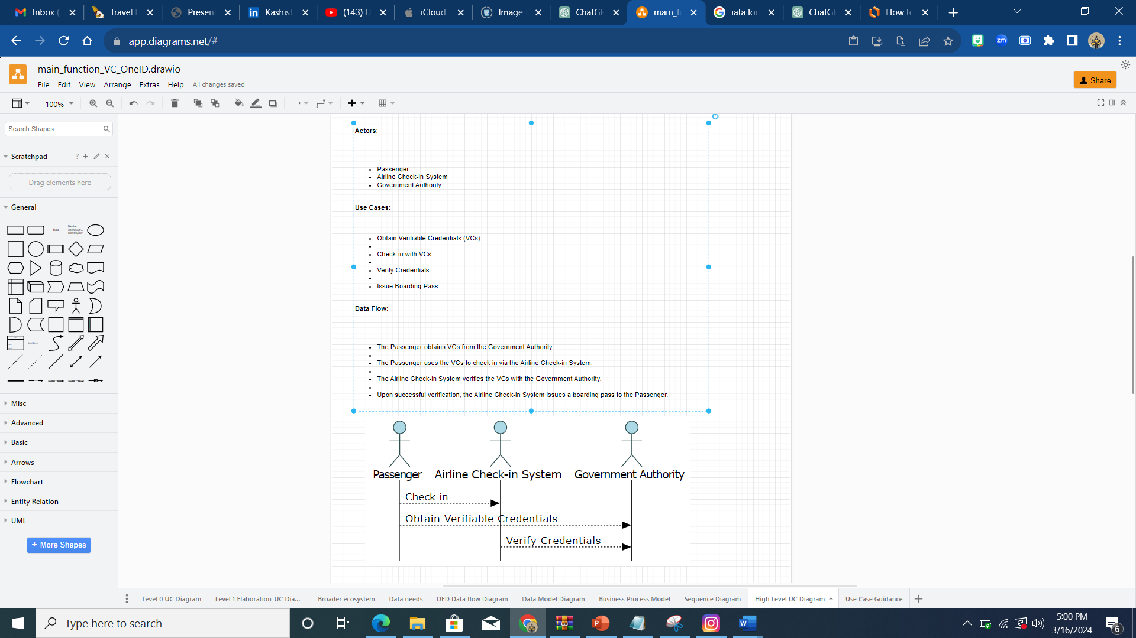

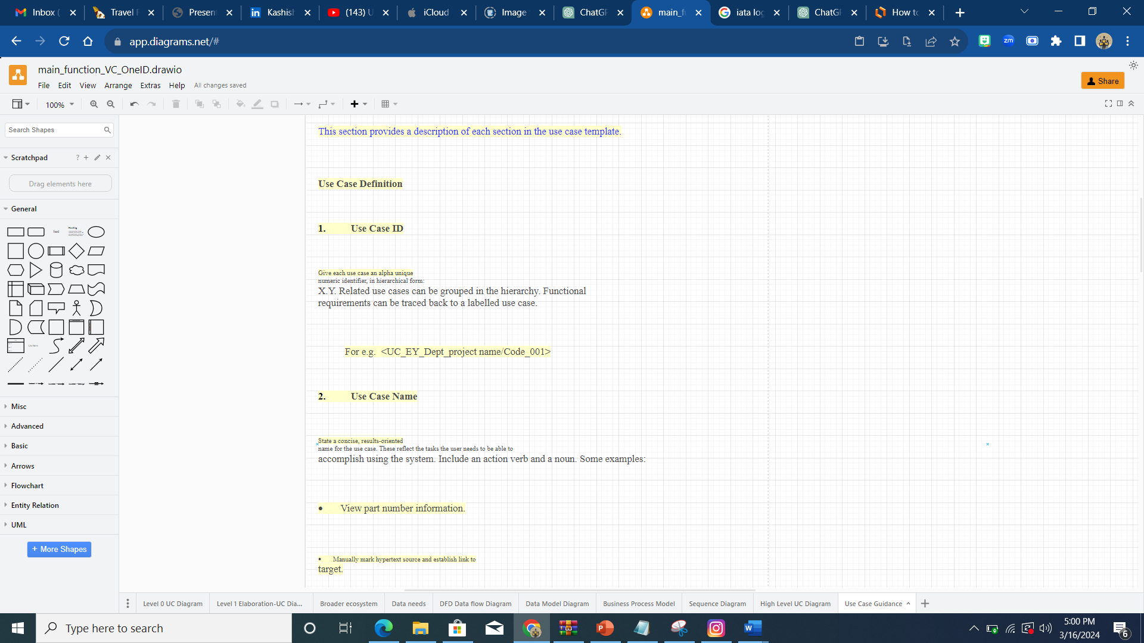

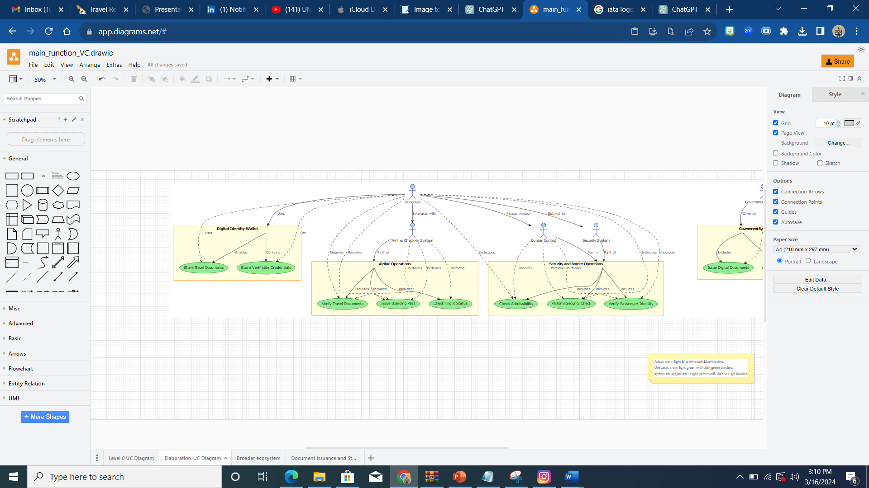

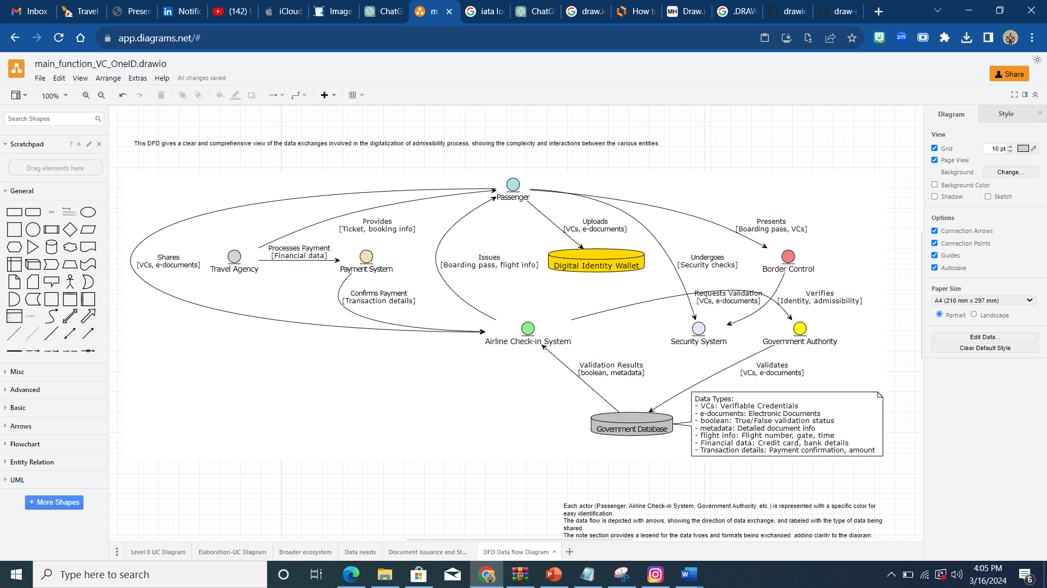

In the digitalization of admissibility with verifiable credentials, several key pieces of data are involved, shared among different actors at various stages of the travel process. Here’s how this data flows:

**Data Involved**

1. **Verifiable Credentials (VCs)**: Digital proofs of identity and travel authorization, such as e-passports and visas.
2. **Personal Information**: Details like name, date of birth, nationality, and travel history.
3. **Travel Documents**: Electronic versions of traditional travel documents, including tickets and boarding passes.
4. **Flight Information**: Details about flight times, gate numbers, and seat assignments.
5. **Security and Health Data**: Information required for security checks and health clearances, if applicable.

**Shared By Whom, With Whom, and When**

1. **Government Authorities to Passenger**
   * **What**: Issue digital documents like e-passports and e-visas as verifiable credentials.
   * **When**: Before the travel process begins, at the time of document application and issuance.
2. **Passenger to Airline Check-in System**
   * **What**: Share verifiable credentials and necessary travel documents.
   * **When**: During the online check-in process or at the airport kiosk prior to the flight.
3. **Airline Check-in System to Government Authorities**
   * **What**: Verify the authenticity and validity of the verifiable credentials.
   * **When**: Immediately after the passenger shares their VCs, before issuing the boarding pass.
4. **Airline Check-in System to Passenger**
   * **What**: Issue boarding passes and flight information.
   * **When**: After successful verification of the passenger’s credentials, usually completed during the check-in process.
5. **Passenger to Border Control and Security System**
   * **What**: Present verifiable credentials and boarding passes for identity verification and admissibility checks.
   * **When**: At the airport, during security screening and border control checks before boarding the plane.
6. **Travel Agency to Payment System**
   * **What**: Share booking details and payment information.
   * **When**: At the time of booking or purchasing tickets.
7. **Payment System to Airline Operations**
   * **What**: Confirm payment and ticketing details.
   * **When**: After the ticket purchase, before the travel date.

This data exchange ensures that each party involved in the travel process has the necessary information to perform their roles efficiently and securely, facilitating a smooth travel experience for the passenger.